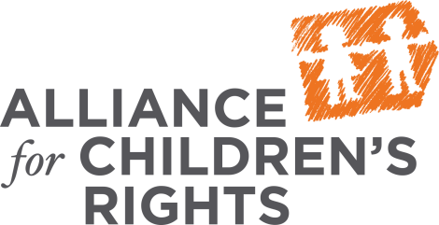

March 16, 2015

VIA ELECTRONIC MAIL

Assemblymember Ken Cooley
State Capitol, Room 3146
Sacramento, CA 95814

RE: Support for AB 423: Supporting Foster Children Placed with Relatives

Dear Assemblymember Cooley:

The name of your org is pleased to sponsor Assembly Bill 423, a bill that will ensure that children in foster care who are placed with relatives have seamless access to the newly created Approved Relative Caregiver Funding Option program.
[Describe your organization and the work you do with relative caregivers]
Fortunately, newly enacted legislation creates the Approved Relative Caregiver (ARC) Funding Option Program and allows foster children placed with relatives additional funding. This is an exciting development that stands to benefit thousands of our state’s most vulnerable children. However, to be successful, it is essential that the program be administered in such a way that is easy to understand and readily accessible for our relative caregivers. Further, because the program is optional, some counties may choose to forego the additional benefits available to relative caregivers. In those counties, it is critical that the relative caregivers gain access to the only remaining sources of assistance through our CalWORKs program.
AB 423 removes and reduces administrative barriers that have been erected that may prevent some relative caregivers from accessing the ARC program. In addition, for counties that decide not to opt into ARC, AB 423 will ensure that relatives caring for foster children in that county have seamless access to CalWORKs funds by requiring the county child welfare office to secure the funding on behalf of the relative caregiver. Finally, AB 423 allows families who are receiving either ARC funds or CalWORKs funds to also access some additional benefits, as appropriate, including Supplemental Security Income and the infant supplement.
AB 423 continues to advance the cause of our relative caregivers and remove barriers that prevent them from accessing benefits in the same manner that they would be able to if they were non-relatives caring for the same child. We urge your support on this important legislation and ask that you make its passage in Assembly Human Services Committee a top priority. If you have any additional questions, please do not hesitate to contact me.

Sincerely,

[your signature]

